Suzanne M. Litrel, Ph.D.
suzannelitrel.com
2026 American Historical Association Conference
Teaching the Global Past: Strategies for Using Primary Sources
Women’s Work? Latin America in World History

- Into the archives and out in the open: gendering action, movement, and effort
Consider patterns of agency, collaboration, and coordination

- Context and “historical imagination”: Contemporary Fiction and Art:

- In Their Own Words: Latin America through the Lens of Women’s Experiences
Diving in: In class or as an assignment, pair the experiences of each of the following with women or similar or starkly different backgrounds. *

Conquest and Empire-Building

Catalina de Erauso, “Lieutenant Nun” (1592-1650)
Note: All excerpts are from Catalina de Erauso’s Lieutenant Nun: The True Story of a Cross-Dressing, Transatlantic Adventurer Who Escaped from a Spanish Convent in 1599 and Lived as a Man, transl. by Michele and Gabriel Stepto (Boston: Beacon Press, 2011)
- American Adventures
In 1600 Catalina escaped the convent and within three years she made her way unrecognized on her uncle’s ship to Panama. “Don Antonio” found employment with a treasury agent for Panama and later worked for a merchant receiving goods and sending them on. She was later sent to conduct business on his behalf in the city of Trujillo:
With another book like the one I had used …containing information about the stock, the prices, and the accounts of credit. (14)

Catalina/Antonio became a soldier and fought in the Battle of Valdivia (1820):
I had taken a bad blow to the leg, but I killed the [Mapuche] chief who was carrying the [company] flag, pulled it from his body and spurred my horse on, trampling and killing and slaughtering more men than there are numbers—but badly wounded, with three arrows in me and a gash from a lance in my left shoulder which had me in great pain—until at last I reached our own lines and fell from my horse. (20)

- Confessions
After years in the Americas, Catalina/Antonio admitted to being a woman, and in 1624 sailed to Spain.
I came to Madrid and presented myself before the king (Philip IV), and begged him to reward my many services, which I had outlined in a memoir that I placed in the royal hand. The king referred me to the Council of Indies, and there I went to present what few papers I had managed to snatch from the wreck of my life. They received me and ruled in my favor, granting me, at the king’s suggestion, a pension of eight hundred crowns a year which is a little less than the sum I had asked for. These events occurred in the month of August, in the year 1625 .…
I left Genoa for Rome. I kissed the feet of the Blessed Pope Urban the Eighth, and told him in brief and as well as I could the story of my life and travels, that I was a woman, and that I had kept my virginity. His holiness seemed amazed to hear such things, and graciously gave me leave to pursue my life in men’s clothing, all the while reminding me it was my duty to lead an honest existence from that day forward, that I must refrain from harming my fellow creatures, and that His commandment thou Shalt Not Kill, carried with it the vengeance of God for those who transgressed. (78-79)

- 1630: Back to Spanish America
In 1693, the priest Nicolás de la Rentária shared that in Veracruz, 1645, he saw the Lieutenant Nun Catalina da Erauso (who went by the name Antonio de Erauso):

She had a mule pack with which she, along with some slaves, carried stuff all over, and that on those mules and with the help of those slaves, she transported goods to Mexico; that she was the King’s subject and known as a person with much courage and skill; that she went in men’s clothing, and wore a sword and dagger ornamented in silver. She seemed to be about fifty years old, of strong build …(xliii)

Reflection Questions/ Activity
- What do these excerpts reveal about the extent and nature of Spanish reach, rule, and control in Americas? What does Catalina’s ability to find employment reveal about economic activity in and about the Viceroyalty of Peru?
- Why would the king of Spain and Pope Urban XIII bestow honors and grant privileges to the “Lieutenant Nun”?
- Compare with the above with excerpts from the Respuesta (The Answer) of Sor Juana Inés de la Cruz (1651-1695) How do both women “weaponize” their life stories?

Revolution

Maria Leopoldina of Brazil (1797-1826)

On September 2, 1822 Leopoldina penned the following to her husband Pedro I. Five days later, he received this, as well as other documents from the State Council on September 7, 1822 at the banks of the Ipiranga River. On that day, he declared Brazil’s independence from Portugal.

Pedro, Brazil is like a volcano. Even in the palace there are revolutionaries. Even the Portuguese are revolutionaries. Even commanders of the troops are revolutionaries. The Portuguese Cortes order your immediate return, threaten and humiliate you. The Council of State recommends you stay. As a woman and wife, my heart senses disgrace if we leave now for Lisbon…
In your hands, Brazil will be a great country. Brazil wants you as monarch. With or without your support, [Brazil] will separate. The apple is ripe, pluck it now, or it will rot … Pedro, this is the most important moment of your life…. You have the support of all of Brazil, and there is nothing the Portuguese soldiers can do against the will of the Brazilian people.

Note: My translation. José Theodoro Mascarenhas Menck, D. Leopoldina, Imperatriz e Maria do Brasil: obra comemorativa dos 200 anos da vinda de D. Leopoldina para o Brasil (Brasília: Mesa da Câmara dos Deputados, 2017): 80-81.

Document analysis/ suggested activity
- Students may compare the “revolutionary” activities of Dona Leopoldina to that of other contemporary women engaged in nationalist and independence movements. *Pair with, for example, the experiences of Micaela Bastidas (1744-1781); Policarpa Salavarrieta (1795-1817)

- Compare various portraits—by men and women-- of Leopoldina. For additional background and lesson ideas, see also From the Margins to the Centre: Brazil in Atlantic and World History (open access, World History Connected February 2020).

III. Nation-state Formation

Clorinda Matto de Turner (1852-1909)

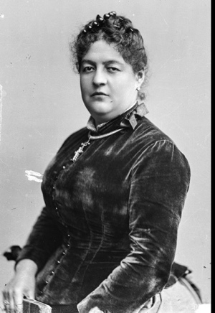

How and in what ways did an indebted Peruvian writer, educator, and widow help spark reform in globally connected, modernizing Peru?

World-historical context: Guano boom and Chinese labor; global feminism; women’s role in modernizing societies; enduring plight of the Quechan and other indigenous people.

*Pair with, for example, the experience and effort of Gabriela Mistral (1889-1957)

- Setting the (world historical) stage: Peru in the Age of Guano –and Beyond
- Modernization, a “woman’s place,” and the plight of the Indigenous
- Inking change, pushing reform: writer, editor, publisher—the importance of strong female mentors (compare and contrast, e.g. Sor Juana Inez de la Cruz)
- Beyond the Salon: Clorinda vs. Catholic Church

Source material: strategies in “reading” the fine print

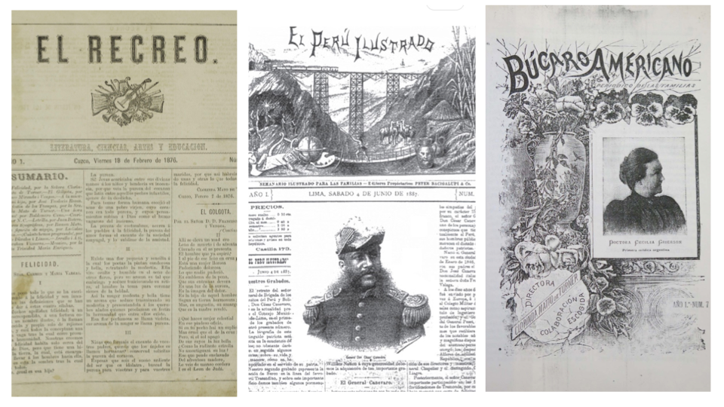
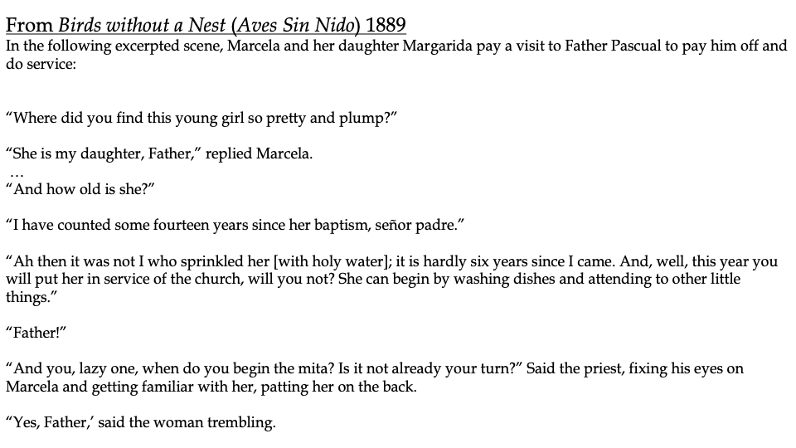
For additional primary source analysis (advertisements, photos, painting, literature): please see AHA 2026 slides in the first item after clicking the “Events” at suzannelitrel.com

